Grade 2
Count to Ten

Description: | Students will:  Make an interactive book about counting.  Paint each number from 1 to ten.  Type the name of the number.  Illustrate each page with the number of objects representing the number on the page.  Create scripts to make the illustrations move.
Project View | 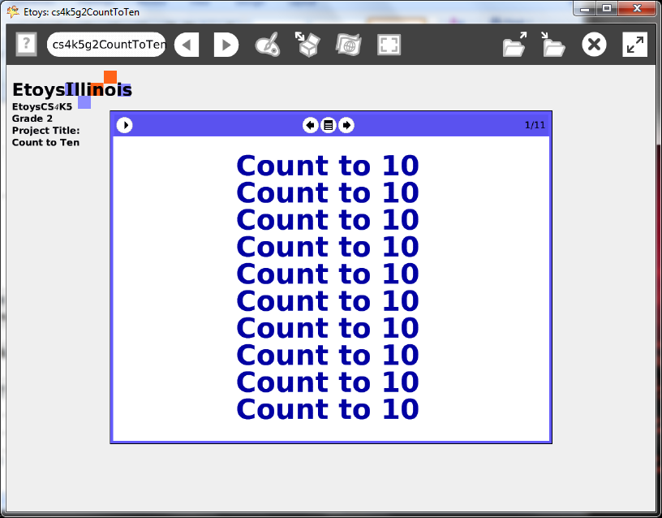
Subject: | Mathematics, Language Arts
Etoys Quick Guides | Click the question mark in Etoys to open the set of interactive tutorials for basic tools and techniques.
Vocabulary: | Add, increase, subtract, decrease, counting, one to ten, shapes, triangles, squares, even and odd numbers, rows and columns, books, pages, how many, where, clocks, time, digital, analog,
Lesson 1:  Books: Top Border Icons  Books: Expanded Controls  Supplies: Text  Books: Working with Layers | This book project is designed to give older (2nd grade) students a purposeful project that can help younger students learn their numbers.  It is a large project that gives students experience combining ideas from mathematics, art, language arts and programming. It can be done a page at a time and over a long period of time.  Give students time to revise their pages, text, colors, and illustrations.  Give students time to read books by other students in the class.  Discuss counting and ask if students have favorite numbers or if they like counting by 2’s or 5’s or ten’s. This example book counts from 1-10 but other ideas are welcome. A book counting from 15-20 could be interesting to someone. All the books do not need to be the same.  If your class is studying a science topic or a story or poem the books illustrations could be applications of those ideas or characters.  The illustrations scripts will use tiles students are familiar with already or new ones they need to make things move as they imagine. The example book uses: forward, turn, bounce, and stamp tiles  Open scripts for objects to see more information.  Use a real book as an example to help students understand the parts of the book, a real book and a virtual one. Proficiency in working with layers takes time to develop.  Open a book from Supplies and click the left arrow to open more options. Add pages.  Type a title on page one.  Paint the number and put it on the next page. Add an illustration and type the name of the number. Include an All Scripts from Supplies.  This book uses the following scripts:  Page 1 copy the text with the yellow halo handle  Page2 turn by  Page 3 forward by  Page 4 turn by  Page 5 turn by  Page 6 turn by  Page 7 conditional statement, forward by, turn by  Page 8 forward by, turn by, bounce  Page 9 forward by, turn by, positive and negative numbers  Page 10 forward by, turn by, bounce  Page 11 forward by, turn by, headings 0 &180, stamp, erase pen trails  Keep the project. Name it: NameCounts e.g. KateCounts
Standards:  Paint Tools | Common Core Standards  Mathematics: 2.OA.1; 2.MD.7  Language Arts: 2.W.6; 2.L.5.a.b  Bloom’s Taxonomy/Cognitive Domain:  Knowledge: knows  Comprehension: gives examples  Application: produces, uses, changes  Analysis: analyzes, compares, experiments  Synthesis: categorizes, explains, creates, modifies, plans  Evaluation: compares, reviews  NETS:  1. a, b  2. b  4. a, b  5. a, b, c, d
Resources: | Etoys Help Quick Guides: always available in Etoys. Open Etoys and click the question mark to open a set of interactive tutorials of basic tools and techniques.  www.etoysillinois.org projects, lesson plans, software download  www.mste.Illinois.org more math, science, and technology resources  www.corestandards.org Common Core Standards  www.squeakland.org software and Etoys projects  www.nctm.org Standards and Focal Points for each grade level
kh
January 2011

